Code Opens Listing
Methodology and Approach
Date: 2/7/18
Revision: 1.0
Author: Justin Reina

Summary:
The Task view in Eclipse is used for tracking project opens ('todos') and a simple methodology is shown here for use.

Item Insertion
- Listing of single items (prefix with '@todo')
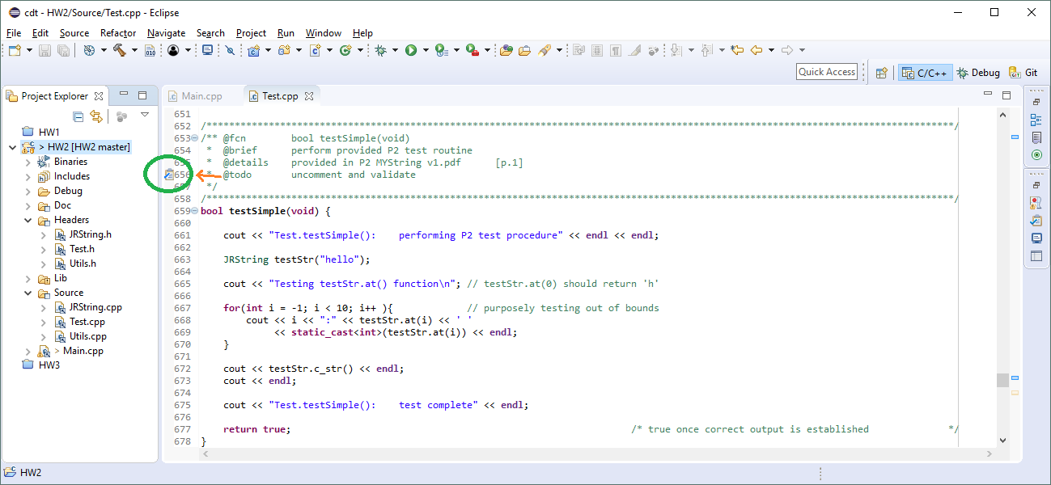
- Listing of list items ('@section Opens', prefix each with '@todo')
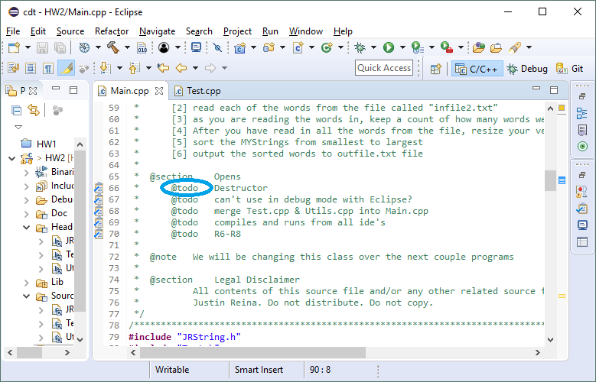

Item Review
- All items listed in source (*.cpp, *.c, *.h) will be included in the Eclipse Task view automatically
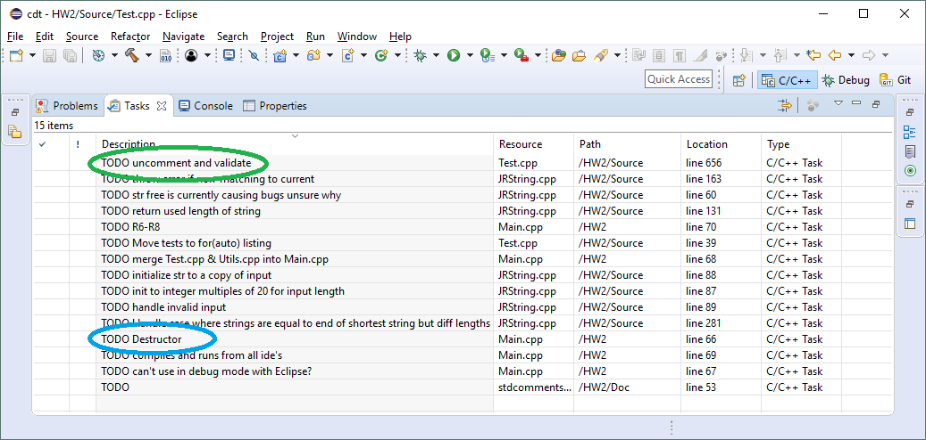
  - Window-> Show View → Tasks
  - note that the colored items listed here match the items shown on first page

